**Software Testing Assignment**

Module -1 [fundamental]

* **What is SDLC?**

SDLC stand for Software Development Life Cycle. It is a systematic process used by software developers to design, develop, test and deploy the software application. The main goal of SDLC is to produce high quality product that’s meets user requirement. It has different phases-

1. Requirement gathering/ analysis phase- In the requirement phase we understand what the client or user expectation.
2. design phase – In design phase we can create blueprint of software architecture.
3. Implementation- In the implementation phase actual development or coding take place.
4. Testing phase- In the testing phase developed software thoroughly tested by testers to find out bugs, defect or error.
5. Deployment phase- In these phase tested software released to live environment so that end user can start using it.
6. Maintenance phase- In the maintenance phase the software has been monitor and update after it has been deploy.

* **What is software testing?**

Software testing is a process used to identified the correctness, completeness and quality of developed software product. The main goal of testing is to ensure the quality, reliability and performance of the software.

* **What is agile methodology?**

Agile methodology is a modern approach to software development that focus on

1. Costumer collaboration over negotiation.
2. Working software over detail documentation.
3. Responding to a change over following a fixed plan.
4. Individual and interaction over processes and tool.

* **What is SRS?**

SRS stands for software requirement specification. SRS is a detailed document that describe what software will do and how it behave. SRS is creating during requirement analysis phase.

* **What is oops?**

OOPS stand for object oriented program. It is a programming approach where we design software using object. Each object represent a real world entity and contain data and method. OOP make program easier to manage; reuse, and scale. The main principle of OOP are encapsulation, inheritance polymorphism, and abstraction.

* **Write the basic concept of OOPS.**

OOPS stand for object oriented program. It is a way of writing computer program using object.

Main concept oops-

***Class***- Class is structure in which we can have member function and member variable.

***Object***- Object is a instance of class and it has state and behaviour.

***Inheritance***- To excess property of one class into another class is called inheritance.

there are five types of inheritance-

* 1. Single
  2. Multilevel
  3. Multiple
  4. Hierarchial
  5. Hybrid

***Polymorphism***- Same function name but having different functionality is called polymorphism.

It has two type-

* 1. Overriding
  2. Overloading

***Encapsulation***- To wrapping the data into single unit called encapsulation.

***Abstraction***-Hiding complexity and showing only importance detail.

* **What is object?**

Object is a instance of class and it has state and behaviour.

* **What is class?**

Class is structure in which we can have member function and member variable.

* **What is encapsulation?**

To wrapping the data into single unit called encapsulation.

* **What is inheritance?**

To excess property of one class into another class is called inheritance.

there are five types of inheritance-

1. Single
2. Multilevel
3. Multiple
4. Hierarchy
5. Hybrid

* **What is polymorphism?**

Same function name but having different functionality is called polymorphism.

It has two type-

1. Overriding
2. Overloading

* **Write SDLC phase with basic introduction**.

SDLC stand for Software Development Life Cycle. It is a systematic process used by software developers to design, develop, test and deploy the software application. The main goal of SDLC is to produce high quality product that’s meets user requirement. It has different phases-

1. Requirement phase-In requirement phase we understand what the client or user needs. We collect the requirement from client. Then we create the document called SRS [software requirement specification here.
2. Design phase- It is a phase where we can create a architecture and blueprint of the software based on requirement define in SRS.
3. Implementation phase- Implementation phase also called development phase where the actual codding take place. Based on design document developers write the code to build the functionality. It turns the plan design into real working system.
4. Testing phase-In the testing phase developed software were thoroughly tested by tester. The goal of testing is to ensure the quality and performance of developed software product to check that software meets the requirement define in SRS.
5. Deployment phase-The deployment is the phase where the tested software is released to the live environment so that end user can start using it. These phase makes the software available to costumer or end user.
6. Maintenance phase-the maintenance phase is the final phase of SDLC where the software has been updated and monitor after it is released

* **Explain phases of waterfall model.**

Waterfall model is a tradition software development model where the process is carried out in linear and sequential order means the process flaw in one direction like waterfall. In these each phase must be completed before next one start.

It has following phase-

1. Requirement phase-In requirement phase we understand what the client or user needs. We collect the requirement from client. Then we create the document called SRS [software requirement specification here.
2. Design phase- It is a phase where we can create a architecture and blueprint of the software based on requirement define in SRS.
3. Implementation phase- Implementation phase also called development phase where the actual codding take place. Based on design document developers write the code to build the functionality. It turns the plan design into real working system.
4. Testing phase-In the testing phase developed software were thoroughly tested by tester. The goal of testing is to ensure the quality and performance of developed software product to check that software meets the requirement define in SRS.
5. Deployment phase-The deployment is the phase where the tested software is released to the live environment so that end user can start using it. These phase makes the software available to costumer or end user.
6. Maintenance phase-the maintenance phase is the final phase of SDLC where the software has been updated and monitor after it is released

* **Write the phases of spiral model.**

Spiral model has four main phases that are-

**Planning phase**- Requirement are gathered from customer .Objective, constrain and alternative are defined.

**Risk analysis phase**-Identify and analyze risk.

Try to find solution.

**Engineering phase**-Actual development and testing takes place.

Build a part of the software.

**Evaluation phase**-Customer evaluate the output of the current spiral.

Feedback is taken for improvement.

* **The agile Write manifesto principle.**

There are 12 agile manifesto principle-

1. Customer satisfaction through early and continuous delivery of valuable.
2. Flexible to change requirement.
3. Deliver working software frequently.
4. Business stakeholders developers must work together.
5. Build project around motivated individual.
6. The most efficient and effective method of conveying information.
7. Working software is the primary measure of program.
8. Agile support sustainable development.
9. Continuous attention to technical excellence and good design.
10. Simplicity-the art of maximizing the amount of working not done.
11. The best architecture requirement and design emerge from self organising team.
12. At regular interval team reflect on how to become more effective.

* **Explain working methodology of agile model and also write pros and cons?**

Agile is a combination of iterative and incremental process model which focus on process adaptability and costumer satisfaction by rapid delivery of working software product. Agile model break the product into small iteration last for one to three weak. At the end of iteration, working product is displayed to the client or stakeholder.

**Pros-**

Promoted team work and cross training.

Work well for changing requirement.

Give flexibility to developers.

Minimum rules and easy to manage.

Support parallel development and delivery

Deliver early working solution.

**Cons-**

Need experience agile leader and project manager.

Hadr to transfer project to new members.

Difficult to go back and change something once the phase is completed.

* **Draw usecase on online bill payment system [Paytm]**

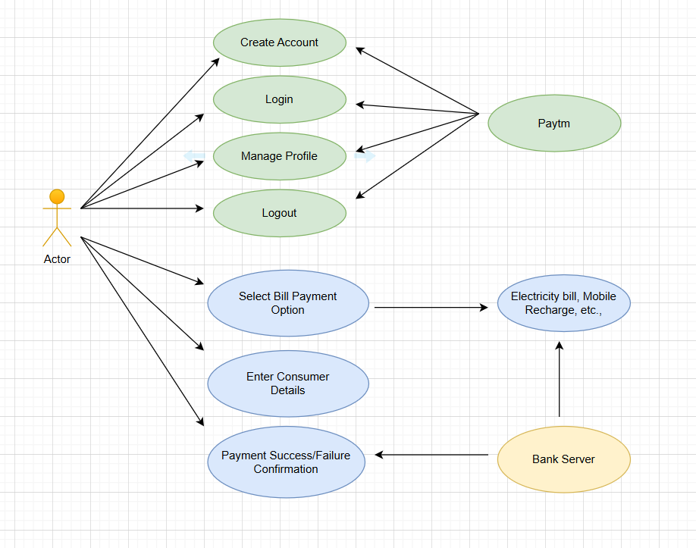

* **Draw an usecase on banking system for costumer.**

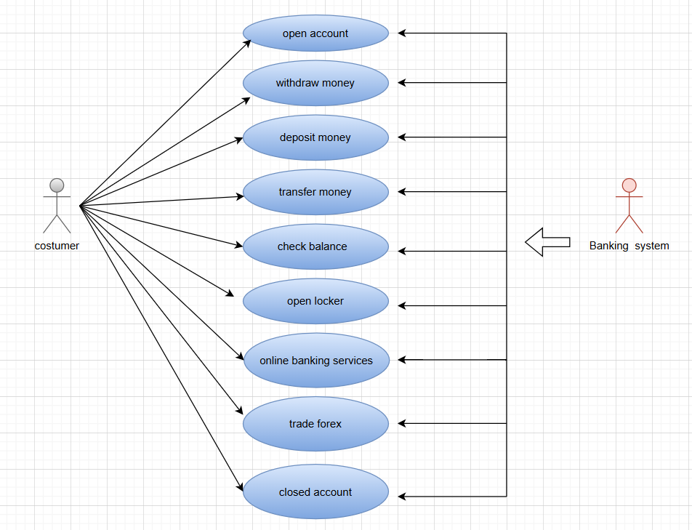

* **Draw usecase on broadcasting system [You Tube].**

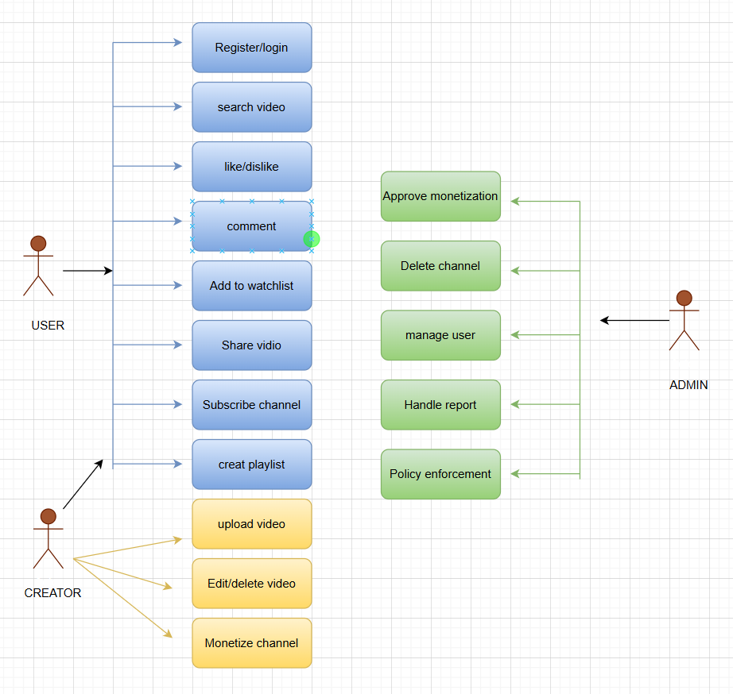

=-*

* **Draw usecase on OTT platform.**

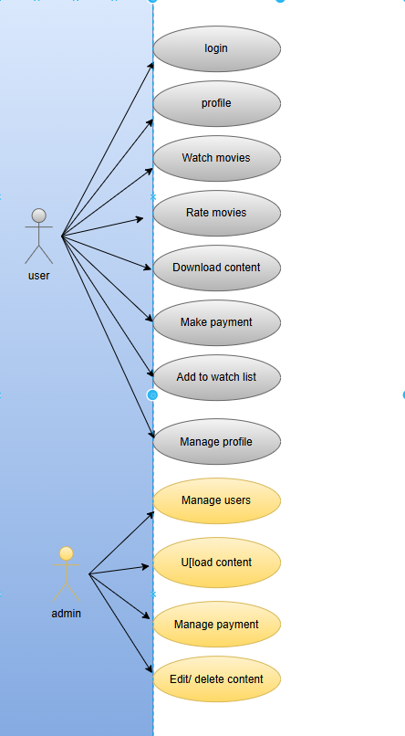

* **Draw usecase on e-commerce application.**

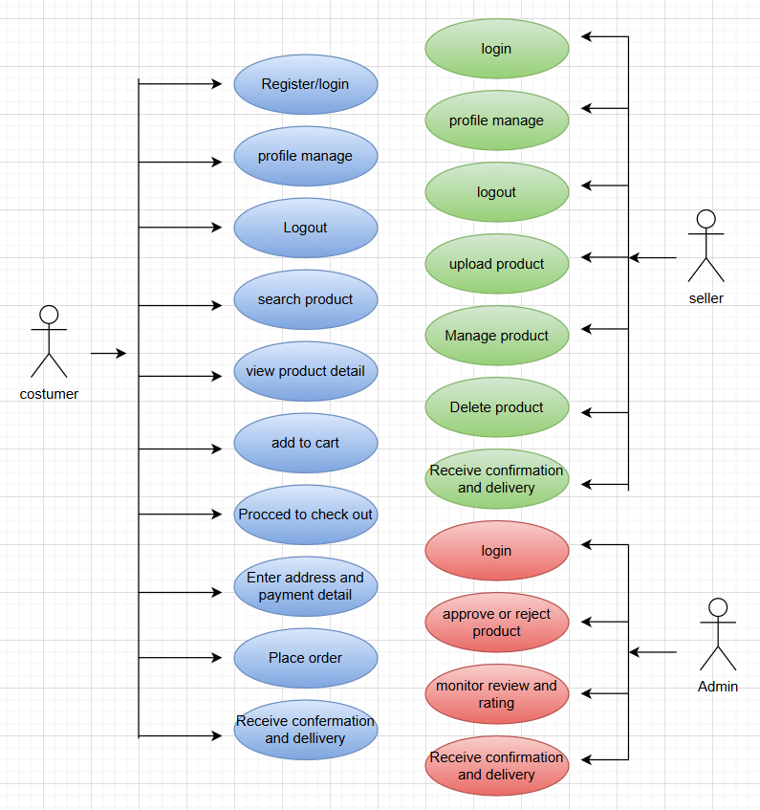

* **Draw usecase on online shopping product using payment getway.**

